WSU Classifieds

https://flinoge.github.io/WeberClassifieds/#/

**Project Group 3**

Richard Dawson

Samuel Doria

Bryan Frist

Trevor Orgill

Aaron Shaneen

# Product Overview

The Weber State University Classified website is a community of students seeking to buy, sell, and trade various items related to life in college. The website is on 24/7, 365 to meet all the needs of students as they come through the halls, classrooms, and dorms of Weber State.

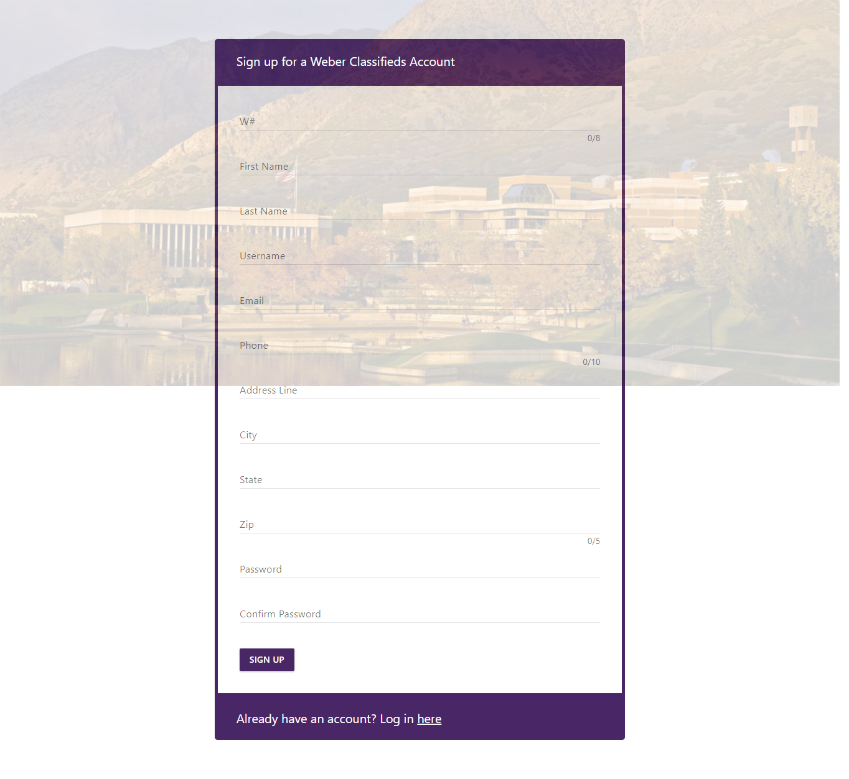With Wildcat pride, we present a safe, secure environment for students with Weber State IDs to transact with their fellow students outside of the traditional avenues of buying, selling, and trading. Gone are the days of creating boring flyers and pinning them around campus,, or scoping out a Craigslist or KSL.com classified ad.

## 

## WSU Students ONLY

If you are a Weber student you can create a WSU Classifieds profile to buy and sell everything from textbooks to lab materials, rooms for rent to tutoring services, and even electronics such as personal computer or scientific calculator, or bicycles and bags.

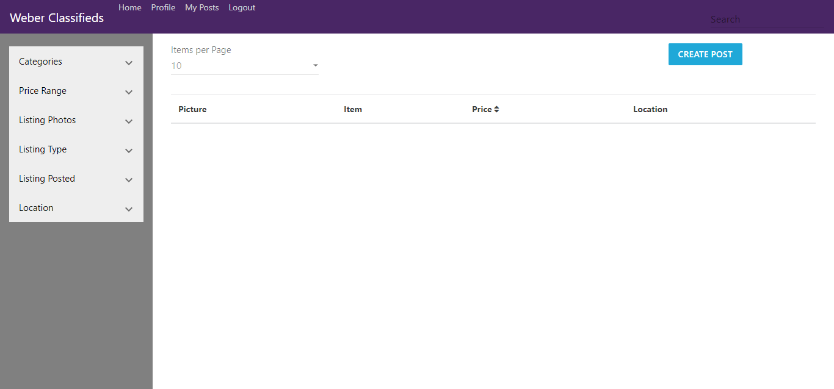

Our website is for wildcats only and allows students to connect with their very own classmates to get what they need. Anyone on Weber State campus can get direct access with an internet connection and a will to barter.

Visit the WSU Classifieds and sign up today.